SMA Webmaster Report: Sep 7, 2017 - Sep 13, 2017
Sean Bruna, Assistant Professor, Western Washington University
sean.bruna@wwu.edu
September 14, 2017

Website Analytics

Visitors
Visitors to the SMA website increased in comparison to the previous year.
- 45,000 Users (10.4% increase from previous year)
- 57,000 Sessions (9.3% increase from previous year)

Top Referrals
Visitors usually visit SMA directly, however, our top four referrals come from:
- americananthro.org
- onlinelibrary.wiley.com
- anthrosource.onlinelibrary.wiley.com
- facebook.com

Global Visitors
Nearly every country visited the SMA website (though many may be bots that automatically search sites). The top referrals come from the U.S., Canada, India, and South Africa

Age of Visitors
Most visitors to the website are younger than 35, with a large number of visitors in the 18-24 age range.
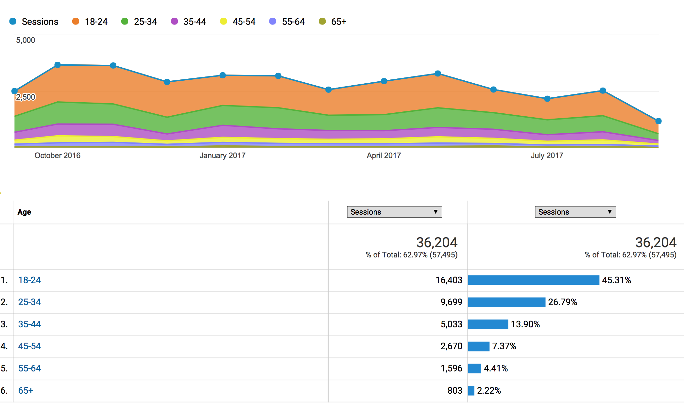

Gender of Visitors
Most visitors to the website are female.

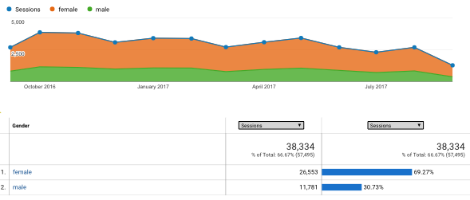

Most Visited Pages
The most visited pages are “About Medical Anthropology”, the home page, and the jobs category:

Page Number of Visitors
- /about/about-medical-anthropology/ 28,188
- Home Page 16,052
- /category/jobs/ 2,457
- /about/ 2,048
- /interest-groups/ 1,347
- /maq/for-authors/ 1,110 (now redirects to the MAQ)
- /category/conferences/ 957
- /policy/prior-statements/global-health/ 804

Devises Used To Access Website
Though most users view the website on a desktop computer, there is increasing traffic by Mobile browsers:

- Desktop: 71.5% (-3.5%)
- Mobile: 25.3% (+4.3%)
- Tablet: 3.1% (-0.8%)

Key Activities

Website Hosting and Design
In the previous year SMA moved website hosting to the American Anthropological Association servers. Working with Vernon Horn, AAA now oversees all “back-end” technical aspects including security and site backup.

A more contemporary, user-friendly and low cost design was implemented in 2017. The new design includes links to our social media platforms (Facebook, Twitter) and an enhanced search function. Unfortunately, this template does not allow for easy modification to highlight SIG posts, as was anticipated in the 2016 report.

The SMA program directory was removed and a link was added to the AAA Program Directory.

Job posts now include a logo in addition to text.

New Webmaster Hired
This year Sean Bruna completed his term as webmaster and the SMA hired Sydney Yeager. Sydney Yeager was been trained by Sean Bruna, will attend an additional training by the AAA webmaster (Vernon Horn), and will assume duties on November 1, 2017.

Fundraising Efforts
In tandem with fundraising efforts, a new donation page was added to SMA and includes both a direct donation to AAA-SMA link, as well as a link to the Amazon Affiliate program. The Amazon Affiliate program provides a small referral payment when visitors make a purchase on Amazon.com after clicking through our referral link.

Recommendations for 2017-2018

- Add content for younger visitors: As indicated by the demographic and technology analytics, it appears as though a younger demographic is visiting SMA. As mentioned to the incoming webmaster, it maybe worthwhile to provide content to a younger audience.

- Design New Logo: We currently do not have a professional logo in the various formats used in print and online media. It may be worthwhile to work with a designer to develop a new logo.

- Highlight Jobs, SIG, Policy, and Conference Pages: visitors are increasingly viewing job postings, information on SIGs, policy briefs, and conference-related posts and pages. It may be worthwhile to further enhance these pages in our various media platforms.

